**SEES PROJECT**

**Spatial Echolocation Enhancement System**

**Progress Report 1**

University of Victoria

CENG/ELEC/SENG 499 Summer 2015

Design Team (Project Number) : 27

Faculty Supervisor : Dr. Fayez Gebali

**Personnel:**

Daniel Faulkner        - V00778450        - SENG (danielafaulkner@gmail.com)

Jason Lim         - V00785426        - SENG (jasonl663@hotmail.com)

Rajpal Chauhan         - V00762290        - ELEC (chauhanraj1000@gmail.com)

John Delorme - V00733268 - ELEC (jdelorme@uvic.ca)

Ian Brown - V00730581 - SENG (ian.campbell.brown@gmail.com)

**Contact Numbers:**

Main: 778-971-0112 (Jason Lim)

Alternate: 250-891-4144 (Daniel Faulkner)

## Summary

The goal of this project is to design a system to aid visually impaired or blind individuals in independently navigating the world around them. Currently, there already exists a variety of aids for individuals suffering from partial or full blindness. While effective in specific scenarios, these solutions are limited in either their capability, usability, or availability. Canes can only be used to detect obstacles nearby and may be intrusive in some scenarios. While guide animals can detect and report on a variety of subjects, they too are limited in availability and applicability.

The SEES project presents a novel solution to this problem through a device that acts as a natural augmentation an individual’s ability to locate and identify objects using audio cues alone. The device is worn as a headset and is mounted with a depth sensing camera used to detect and analyze the environment around the user. Using the information gathered by the depth camera, the system synthesizes and appends spatialized audio cues to objects in the scene and feeds them back to the user through a pair of headphones. Not only does this significantly improve the individual’s personal independence in being able to comprehend the world around them on their own, but it is also provides navigational aid in a manner non-intrusive to both the user and to the individuals around the user.

## Background

This project is a continuation of work done during the 2014 Fall semester ELEC 399 design project. During this time, research was done to determine the best way to design and implement the system. The group decided on the headset model both for its simplicity and ease of use. For the depth camera, the group opted for using a Microsoft Kinect which features long sensing range, low cost, and high availability. Finally, it was decided that audio processing and control of the device would be performed via a mobile phone device with a minimum 1.5GHz processor as this would allow the headset to be usable with the user’s own mobile device instead of requiring specialized hardware.

Spatialized audio cues can be generated with a regular pair of in-ear headphones using Binaural Audio Filtering. With Binaural Audio, audio signals are separated into left and right audio channels and are then filtered with a transfer function reproduces the characteristics of sound entering the ear. The result, when listened to through a pair of headphones, sounds as if the audio signal is coming from the outside of the listener’s ears.

At this point, it should be noted that due to the limited field of view for the depth camera, additional consideration must be made for determining how to express objects as audio cues. Large numbers of indistinct audio cues can be confusing to the user and lead to difficulties in interpreting and understanding their environment. To test this, a software prototype of the system was developed and tested with a simple signalling model. Results from the test indicates that while the current signalling model requires improvement, an optimized signalling model would be able to provide effective environmental based audio cues to the user.

## Milestones

Currently, there are 4 planned milestones for this project as shown in the broken up Gantt chart below:

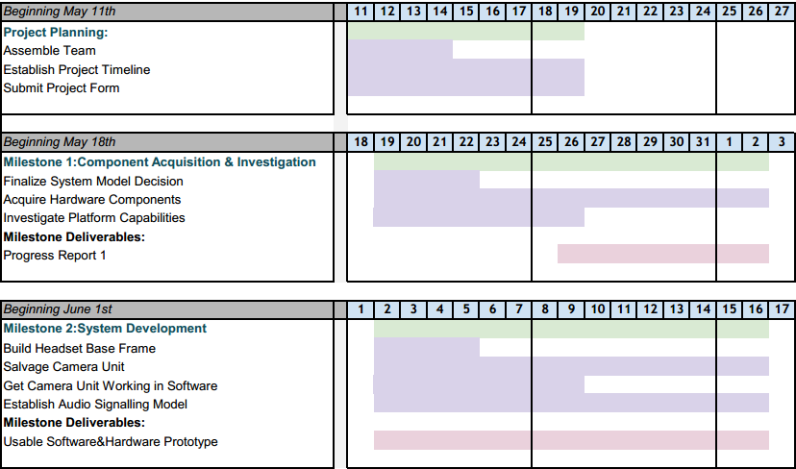

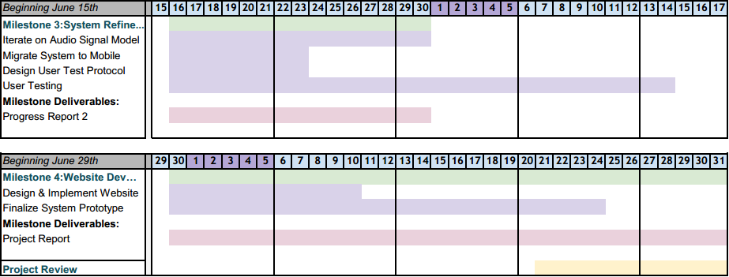

## Progress to Date

Project Planning Phase: During the first week, the team was assembled. New members Ian and John were familiarized with the project, a supervisor was found, the project form was submitted, and a basic timeline was established.

Over the next two weeks, work was undertaken on Milestone 1: ‘Component Acquisition and Investigation’. The focus in this milestone was to decide on the design of the project, acquire the necessary hardware, and investigate the platform capabilities. The milestone also required a progress report on the outcomes of this stage.

Daniel and Jason led the design research due to their familiarity with the project.

Jason, John, and Daniel focused on hardware acquisition, looking at the feasibility and availability of acquiring either the Intel RealSense camera and/or the Kinect, as well as other required parts.

Ian concentrated on mobile development aspects, specifically using the Android NDK in order to run native C++ code on an Android device for fast, efficient Fourier transform computations. He also researched using USB on-the-go to use the mobile device to power the sensor.

Jason additionally researched the Oculus Rift SDK as an alternative for audio processing on mobile without the need to run native C++ code.

Daniel investigated the available options for running the Kinect sensor with an Android device.

Finally, Raj and John put together the progress report, with the rest of the team contributing a number of additions and edits.

In the future, the group will continue to work to the strengths of its members. Raj and John will become more involved in the hardware components once all the parts have been acquired (some are still shipping), and Daniel, Ian, and Jason will focus more heavily on the software side of the project. Project management is currently a shared responsibility, with Jason being the main driving force in terms of vision and design. Group members finding themselves caught up on assigned tasks can additionally work on reports and demonstrations, which will be helpful during periods of time where either the software or electrical side is waiting on the other.